  

**Mirrool Creek Landcare project 2013, Funded by Caring For Our Country Community Partnership projects.**

**Project Partners:** Mirrool Creek Landcare, FarmLink Research, Elders, Landmark, A L Chalmers and Sons

**Aim:** To evaluate moisture infiltration in pasture and cropping paddocks and the effect of varying nitrogen applications on moisture usage and yield.

**Outline:**  Growers in the Ariah Park and Mirrol region of Southern NSW expressed an interest in developing knowledge and skills in improved soil moisture profile mangement to reduce yield loss and maximise profitability. In conjunction with the project partners 3 soil moisture probes and automatic rainfall gauges were installed at 2 sites. One on Felix Farm North west of Ariah Park and the other on Michael & Renae Denyers property south west of Ariah Park.

The probes were installed 20m apart to allow a range of management options to be implemented over each probe. Yield and Plant available water (PAW) levels were recorded. The probes were installed 18cm below the soil surface to allow normal machinery operations to occur without interuption.

**Site 1. Dart, Felix Farm.** The focus of this site was to determine if additional N applications could have an impact on yield and PAW. The probes were installed and commissioned and data was collected from the 2nd of April 2013. Probe 1 was targeted for a high rate of N at 170kg/ha of Urea applied to an established Canola crop that was planted over all 3 probes. Probe 2 had no Urea added to the area surrounding it. Probe 3 was used as a long fallow evaluation and the canola was sprayed out on the 10th of July and the area kept free of weeds over the crop growing phase. Results are tabled below in table 1.

|  |  |  |  |
| --- | --- | --- | --- |
| Probe number | Yield | SMU’s Nov 13 | SMU’s Feb 14 |
| 1 | 1.81t/ha | 406 | 426 |
| 2 | 1.42t/ha | 422 | 441 |
| 3 | Fallow | 480 | 481 |

*Table 1 Yield and PAW data for Dart moisture probe fallow & N treatments. SMU = Soil moisture units*

**Discussion.** The data clearly shows the impact of additional urea applications have had on yield and PAW. Probe 1 yield were 1.81t/ha compared to the nil urea treatment which yielded 1.42t/ha. At a cost of $550/t, 170kg of Urea would cost $93.50. The additional 390kg/ha of Canola was valued at $546/t or an additional income of $213. So the additional urea probe made an extra $119.50/ha in 2013.

**PAW impacts of Urea and Fallow**

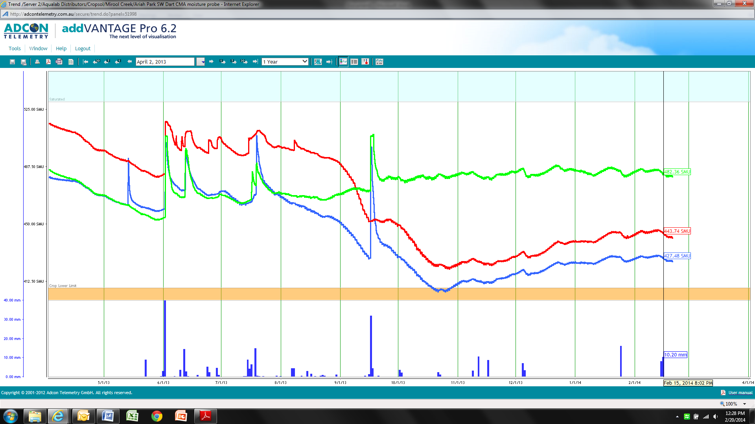

*Graph 1: PAW levels for 3 Dart probes 20th Feb 2014. Green = fallow, Red = nil urea, Blue = 170kg urea.*

Again the PAW impacts of the three treatments are clear. Fallow has retained the most PAW with a reading of 480smu’s at harvest in November 2013. This is a large increase over the two cropped treatments and is 70% of the PAW profile for this site. It is difficult with one years data to establish drained upper limits (saturation point) for probe profiles and this point for these sites is an estimation only. Soil characterization data predicts this site to have a total PAW content of between 170 and 200mm. The knowledge that there is a large amount of stored soil moisture will assist growers to manage crops to maximize potential yield in 2014. Management strategies such as summer weed control, stubble retention, early sowing and additional N applications at sowing could be employed with this aim for probe site 1.

The nil urea treatment had 422smu’s at the same time and this is 14% of the PAW profile. The 170kg urea site had no PAW at harvest. This means the 170kg urea site used all available water down to 1.12m depth. However plants may have been sourcing moisture from below this depth. The PAW at site 2 at present is 441smu’s and equals 32% of the PAW profile. This amount of moisture may be useful for next season’s crop but will not satisfy all of the requirements in a dry year. The level is similar to the beginning of 2012 and below average rainfalls for 2014 will put crops under moisture stress during the growing season, especially in the critical period of spring.

The 170 kg urea site is currently at 426smu’s which is 17% of total PAW profile. Entering a growing season with this amount of stored soil moisture would be concern and some grower may adjust their management according to their aversion to risk. Strategies employed could be late sown quick maturing varieties, reduced crop inputs such as seed, chemical or fertilizer, grazing or hay production or sowing of cheaper to establish crop options such as Barley.

Rainfall is recorded at the bottom of the graph with 171mm having fallen from April 2 to Nov 1 in 2013. This is 59% of average annual rainfall. Water use efficiency calculations allow for 60mm of transpiration and evaporation over this period, this means that the crop would have had 111mm of available rainfall in 2013. This does not account for stored soil moisture from summer falls in 2012/13 but a very dry summer and autumn would have contributed very little PAW at this site. The 170kg urea site had a water use efficiency of 16kg of canola grain for every mm/ha of PAW. This is an outstanding result and shows that the crop used PAW and nutrients very efficiently in 2013. The management strategy of 170kg urea was able to maximize yield potential to a very high level.

**Separate sensors, where was and is the PAW**

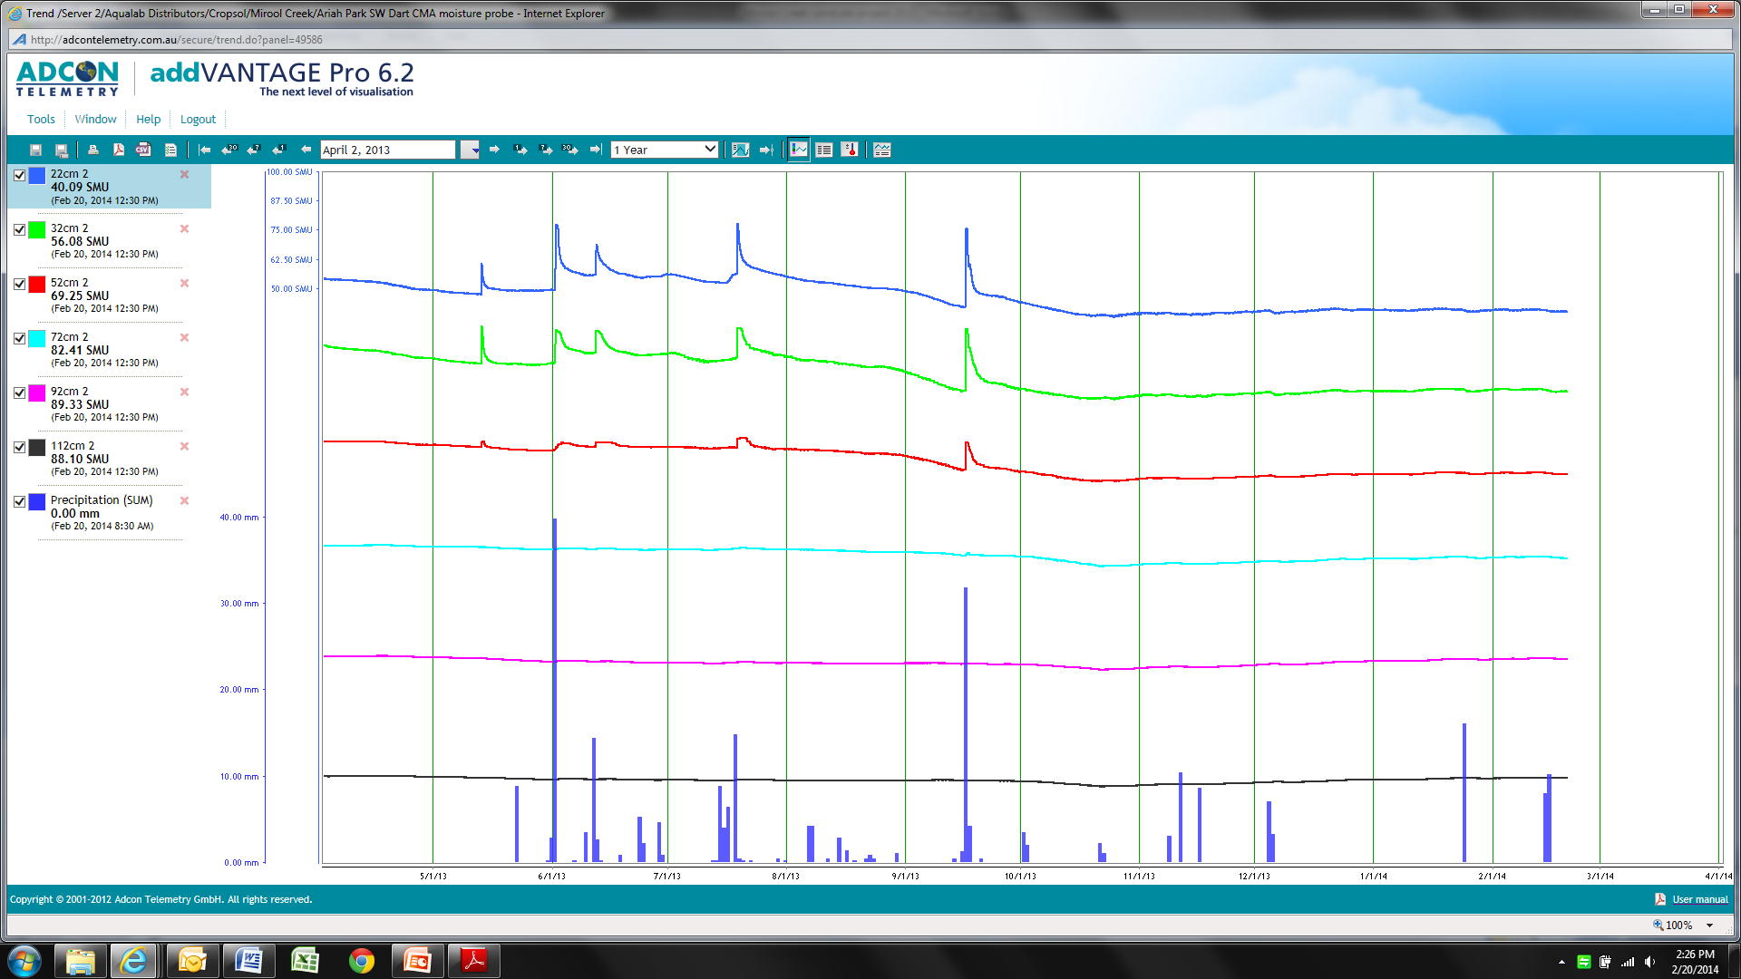

*Graph 2: Probe 1 Dart site, separate sensor graph Feb. 2014.*

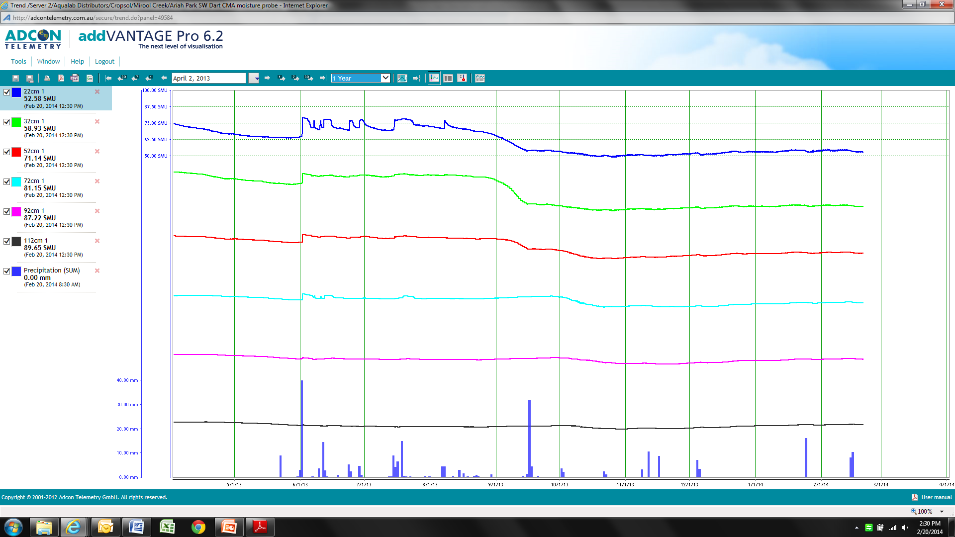

*Graph 3: Probe 2 Dart site, separate sensor graph, Feb. 2014*

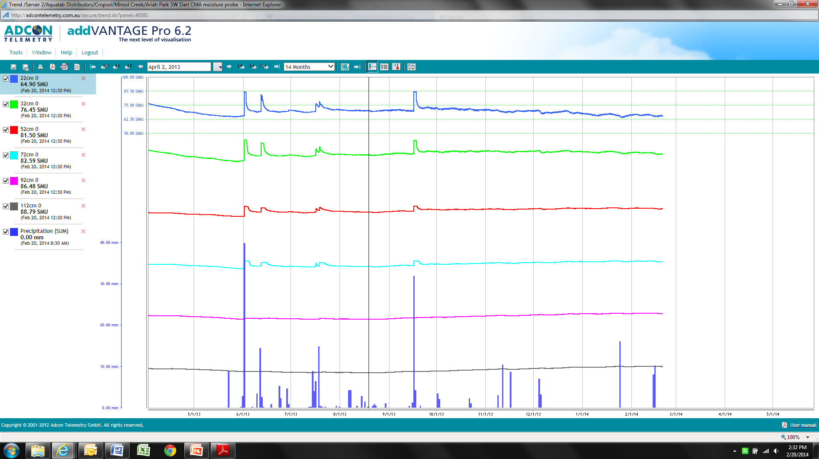

*Graph 4: Probe 3 Dart site, separate sensor graph Feb. 2014*

The separate sensor graphs depict the PAW level at each of 6 sensors that are located at 22, 32, 52, 72, 92 and 112cm depths. The detail of the graphs is difficult to see in the space allowed in this report. Table 2 below gives a better insight into the moisture levels at each sensor for each probe.

|  |  |  |  |  |  |  |
| --- | --- | --- | --- | --- | --- | --- |
| **Depth** | **22cm** | **32cm** | **52cm** | **72cm** | **92cm** | **112cm** |
| **Probe 1** | 39 | 54 | 67 | 79 | 85 | 84 |
| **Probe 2** | 49 | 57 | 68 | 78 | 84 | 86 |
| **Probe 3** | 70 | 79 | 81 | 81 | 84 | 85 |

*Table 2: Separate sensor smu’s for each probe, Dart site Nov 2013.*

The table shows that the long fallow treatment has additional PAW in the 22 to 52cm layers of the profile. There is very little difference in the lower profile. This is considered a result of growing season rainfall being stored during the growing season when no crop was drawing moisture. It was surprising that the lower profiles were not reduced during the season but given the very low starting point of PAW in early 2013 it is highly likely that no rainfall was deposited in these layers for any of the probes. That is, it was dry at the start and stayed dry because of lack of rainfall and crops in probes 1 & 2 using any rainfall during 2013.

**Site 2: Denyers.** The focus at this site was to compare the PAW use and rainfall infiltration between Lucerne/Clover pastures and Canola. Again 3 probes were installed with one located in the pasture and two in the adjacent Canola crop. The canola probes 1 & 2 were treated with 100kg and 200kg of urea respectively.

|  |  |  |  |
| --- | --- | --- | --- |
| Probe number | Yield | SMU’s Nov 13 | SMU’s Feb 14 |
| 0 | Pasture | 321 | 339 |
| 1 | 1.27t/ha | 500 | 483 |
| 2 | 1.42t/ha | 394 | 399 |

*Table 3: Denyer probes yield and PAW data 2014.*

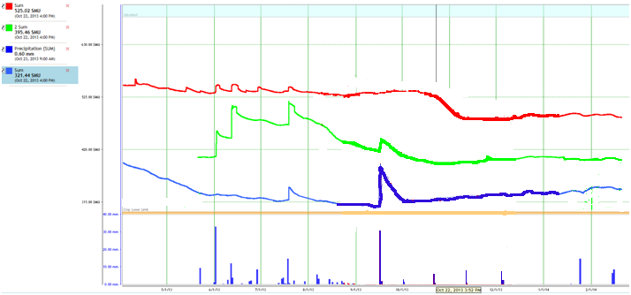

*Graph 5: Denyer probes PAW2013/14. Blue = probe 0 (Lucerne), Red = probe 1 (canola + 100kg urea), Green = probe 2 (canola 200kg urea)*

The probes at this site have experienced problems during the growing season and this affects the reliability of the data and interpretation of results. As with the Dart site with only one seasons data it is hard to establish crop lower and drained upper limits and the thresholds set are estimates at best and may not be an accurate reflection of reality. It was expected that the canola crop would use any available PAW during the below average rainfall growing season but the individual sum graphs for each species are vastly different to each other and the Lucerne? This can be explained to some degree by the differences in moisture at the 72cm depth between the + 100kg urea probe and the + 200kg urea probe. (see graphs 5 & 6)

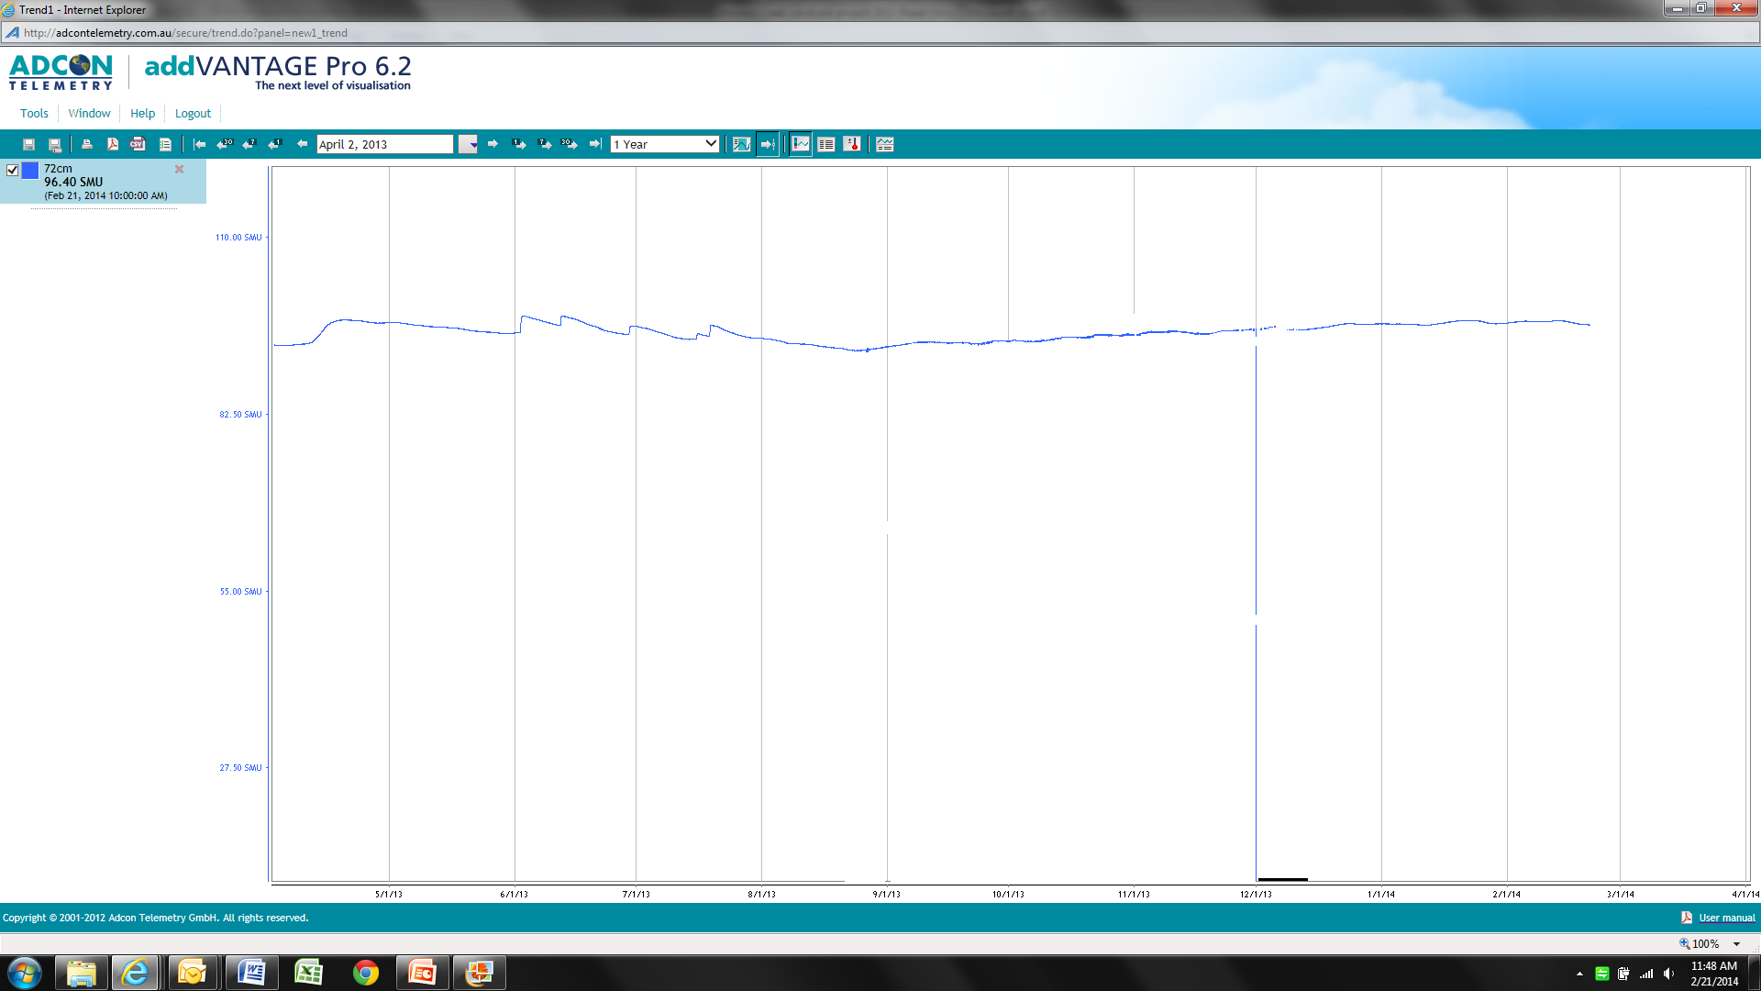

*Graph 5: Denyer probe 1, + 100kg urea, sensor depth 72cm.*

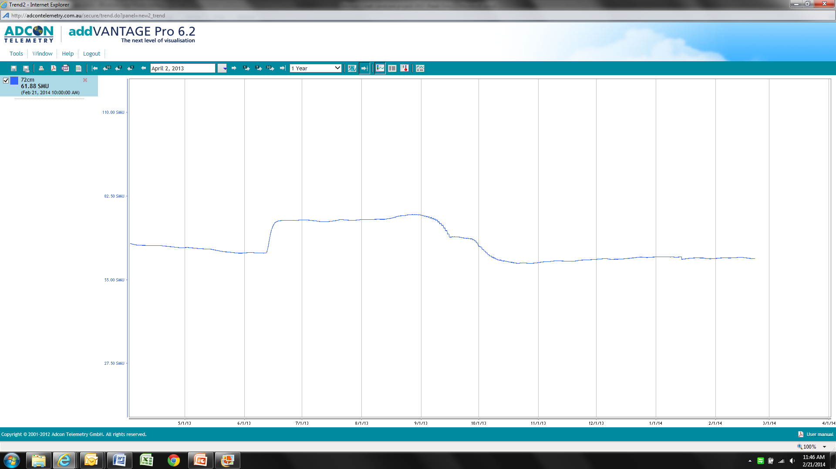

*Graph 6: Denyer probe 2, + 200kg urea, sensor depth 72cm.*

It can be seen that at the depth of 72cm there is a considerably higher reading for smu’s in the +100kg urea probe. This is likely a result of reduced root development not allowing the canola plants to access this moisture. While the yield advantage is small in dollar terms it equals $82 of additional canola yield. The cost of the urea was estimated at $55 so there is a small return on investment in additional urea at this site.

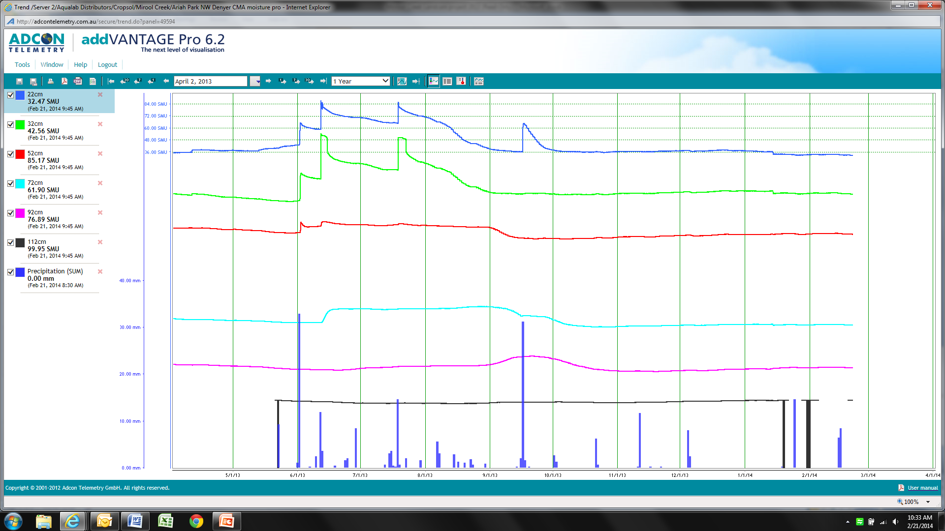

*Graph 7: Probe 0, Canola + 100kg Urea, Denyer site, separate sensor graph, Feb 2014*

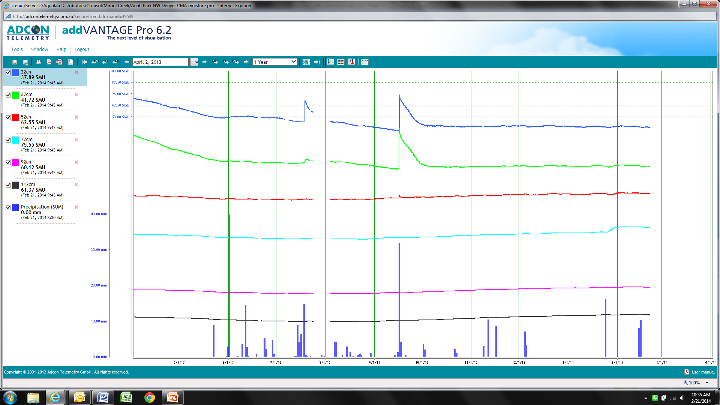

*Graph 8: Probe 2 , Lucerne, Denyer site, separate sensor graph, Feb 2014*

The noticeable variation in these graphs is the level of infiltration following rainfall events. The Canola + 100kg urea records smu levels up to 100 while the Lucerne is far lower at 60-70smu’s. As well the depth of infiltration of moisture down the profile is reduced for the Lucerne pasture as is clearly demonstrated by the rise in smu levels down to 92cm for the Canola crop. The Lucerne pasture was grazed and sheep can compact the surface layer of the soil during prolonged grazing, especially if conditions are moist. The reduced infiltration in the Lucerne pasture is a direct response to this compaction. Another factor is the reduction in ground cover in grazed Lucerne pastures. This, along with shallow compaction, decreases infiltration and increases runoff thus reducing soil PAW levels.

**Conclusions:** The aim of the project was to evaluate a range of N management strategies and pasture grazing on PAW. The project achieved this by installing probes and accurately monitoring PAW levels down to 1.22m for each treatment. There were clear differences between treatments at both sites. As a result of the findings growers will be more confident in the capacity of probes to measure PAW and be able to implement management strategies that are more suited to the PAW identified. In grazing situations management strategies such as “periodic renovation” of paddocks with knife points will open the soil surface and promote increased infiltration and hence increase growth over longer periods.

With N management growers will have an accurate measure of soil PAW and can adjust rates to provide sufficient N for yield estimates related to that PAW level. It is expected that the probes will become more useful over time as more data is collected on a range of seasonal conditions and crops. This experience will provide additional certainty for management decisions that were less informed in the past.